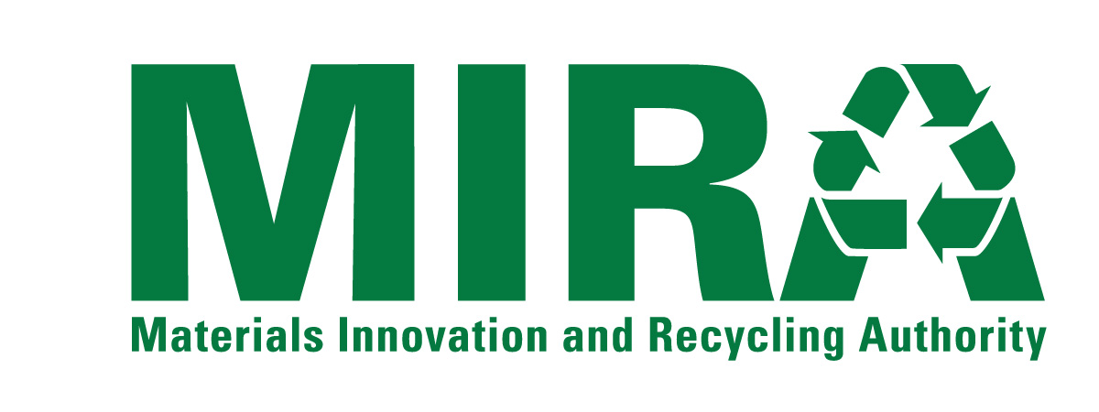
BUSINESS DISCLOSURE FORM

CONFLICTS OF INTEREST
In the space below, disclose any material assignments, relationships or other employment that the Proposer or any employee of the Proposer has with any member of MIRA’s Board of Directors,* any MIRA employee, law firms, governmental entity, or other person or entities that may create a conflict of interest or the appearance of a conflict of interest in providing the Services to MIRA.
*a list of Directors is available on the MIRA website at www.ctmira.org
[Attach Additional Pages If Necessary]

CONFLICT OF INTEREST MEASURES
In the space below, discuss any measures that the Proposer either has in place or would take to identify, disclose and resolve any possible conflicts of interest.
[Attach Additional Pages If Necessary]

INVESTIGATIONS
In the space below, discuss any pending or recent investigations by the Securities and Exchange Commission, the Internal Revenue Service or any other regulatory body or court (local, state or federal) regarding the conduct of the Proposer the Proposer’s management or any individuals assigned to work with the State which might affect Proposer’s ability to deliver the Services described in this RFP. Discuss any such investigation that has occurred during the past two years.
[Attach Additional Pages If Necessary]

BUSINESS WITH MAJOR MIRA CONTRACTORS
MIRA has made payments of over $100,000 a year to the organizations named on the MIRA Vendor List on Page 6 of this Form. If the Proposer has represented any of these organizations (or their subsidiaries or affiliates), in the table below list the name of the organization, the matter(s) on which the Proposer represented the organization and the fees received from the organization in the past three (3) years. Representation of these clients will not necessarily result in disqualification from work with MIRA. The nature and extent of the representation of such clients, appropriate conflict of interest rules and the nature and extent of proposed representation of MIRA will all be considered.
[Attach Additional Pages If Necessary]
Organization | Matter on Which Represented Organization | Fees Received in Past 3 Years

MIRA Vendor List (FY 2014)
Payments Greater than $100,000
AON RISK SERVICES | HARTFORD, CITY OF
BOTTICELLO, INC. | KAINEN ESCALERA & MCHALE PC
CONNECTICARE, INC. | LINIUM STAFFING SVC
COPES RUBBISH REMOVAL | METROPOLITAN DISTRICT COMMISSION
COVANTA SOUTHEASTERN CT | METROPOLITAN LIFE INSURANCE COMPANY ASSET HOLDINGS II, LLC.
CONNECTICUT, STATE OF, DEEP | NAES CORPORATION
CONNECTICUT, STATE OF, DEPARTMENT OF REVENUE SERVICES | NEXTERA ENERGY POWER MARKETING LLC
COVANTA PROJECTS OF WALLINGFORD | NORTHEAST UTILITIES/CL&P
CWPM, LLC | PRESTON, TOWN OF
ET&L CORPORATION | SANTA BUCKLEY ENERGY, INC.
ENVIRONMENTAL CAPITAL LLC | SCS FIELD SERVICES
FCR, INC. | SOUTHEASTERN CONNECTICUT REGIONAL RESOURCES RECOVERY AUTHORITY
FIDELITY INVESTMENTS | TRC ENVIRONMENTAL CORP
FUSS AND ONEIL INC. | WHEELABRATOR BRIDGEPORT LP
GERSHMAN, BRICKNER & BRATTON, INC. | WHEELABRATOR TECHNOLOGIES INC
HALLORAN AND SAGE LLP

