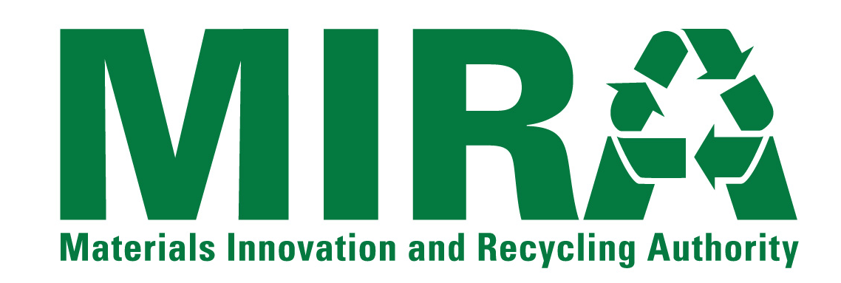
NOTICE OF INTEREST FORM
Individuals and firms that have an interest in the Materials Innovation and Recycling Authority (“MIRA”) solicitation listed below are encouraged to submit this Notice Of Interest Form to MIRA as early as they can. Forms should be submitted no later than the date specified below. Request For Bids/Proposals/ Qualifications documents and other information released by MIRA related to the solicitation will be directly provided to those firms that have submitted this Form to MIRA by the Form Due Date.
Solicitation: | Delivery of Interruptible Contract Waste From December 1, 2014 to June 30, 2015
RFP Number: | RFP 15-OP-002
Provide the following information about the individual/firm and the contact person for the firm.
Name of Individual/Firm:
Name of Contact Person:
Title of Contact Person:
Mailing Address 1:
Mailing Address 2:
City, State, Zip Code
Telephone Number:
Fax Number:
E-Mail Address:
Submit this form to the MIRA contact listed below via e-mail, fax or correspondence as listed below.
MIRA Contact: | Roger Guzowski
E-Mail Address: | rguzowski@ctmira.org
Fax Number: | (860) 757-7742
Correspondence Address: | Materials Innovation and Recycling Authority  100 Constitution Plaza, 6th Floor  Hartford, CT 06103

