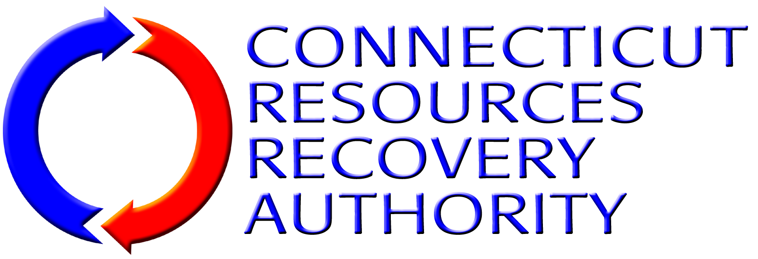
NOTICE OF INTEREST FORM
Individuals and firms that have an interest in the Connecticut Resources Recovery Authority (“CRRA”) solicitation listed below are encouraged to submit this Notice Of Interest Form to CRRA as early as they can. Request For Proposal documents and other information released by CRRA related to the solicitation will be directly provided to those firms that have submitted this Form to CRRA.
Solicitation: | Operation And Maintenance And Commodity Marketing Services at the CSWS Recycling Facility
Facility Location: | 211 Murphy Road, Hartford, CT 06114
RFQ Number: | 13-OP-003
Provide the following information about the individual/firm and the contact person for the firm.
Name of Individual/Firm:
Name of Contact Person:
Title of Contact Person:
Mailing Address 1:
Mailing Address 2:
City, State, Zip Code
Telephone Number:
Fax Number:
E-Mail Address:
Submit this form to the CRRA contact listed below via e-mail, fax or correspondence as listed below.
CRRA Contact: | Roger Guzowski
E-Mail Address: | rguzowski@crra.org
Fax Number: | (860) 757-7742
Correspondence Address: | Connecticut Resources Recovery Authority  100 Constitution Plaza, 6th Floor  Hartford, CT 06103

