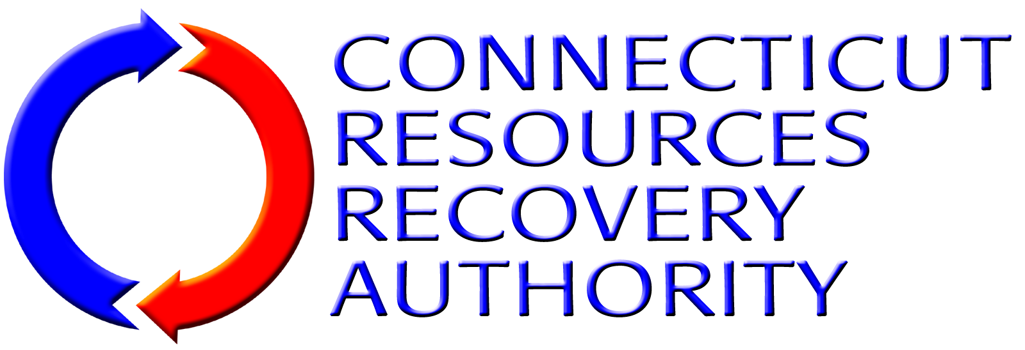
BUSINESS EXCEPTION FORM
If submitting a proposal for Option 1, 2, or 3 as detailed in Appendix A of the Instructions To Proposers (Section 3.1 of the RFP Package Documents), using this form (add additional sheets of paper as needed), Proposer (hereinafter collectively referred to as “Contractor”) shall identify any portion of the Work/Services required or any portion of the “FORM OF THE AGREEMENT FOR OPERATION AND MAINTENANCE SERVICES [AND/OR] COMMODITY MARKETING FOR THE CSWS RECYCLING FACILITY” (the “Agreement”) identified in the RFP Package Documents as substantially non-negotiable that Contractor desires to take exception to, if any.
Contractor shall be specific regarding any exceptions listed. Contractor shall describe in detail the portion(s) of the Work/Services Contractor is taking exception to and why. Contractor shall also describe what, if any, alternative Work/Services or conditions Contractor is willing to provide or accept as a substitution for the Work/Services or business terms to which Contractor has taken exception, if any. If Contractor does not take exception to any portion of the Work/Services required or described in this RFB/P/Q Package Documents and the Agreement, Contractor shall simply indicate below that Contractor “takes no exceptions”, and submit this form along with the other Bid/Proposal/SOQ forms as part of its Bid/Proposal/SOQ submittal.
Note that CRRA expects to negotiate with Contractor on only those items identified as negotiable in the RFP Package Documents or identified by the Contractor on this Business Exception Form, but reserves the right to negotiate any terms of the Agreement with the Contractor. Also note that pursuant to State of Connecticut statutes and regulations, the Agreement contains a number of provisions that CRRA, as a quasi-public entity, is required to incorporate in all of its contracts and are, therefore, non-negotiable.
Description of Exception Item |  | Reason for Exception | Proposed Alternative
1.
2.
3.
4.
5.
6.
7.
8.
9.
10.

