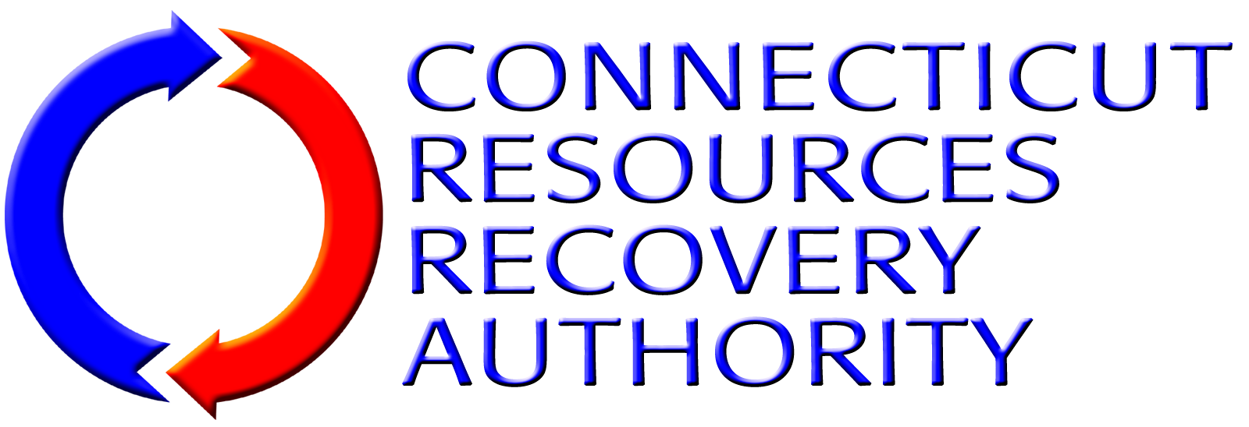
EXPRESSION OF INTEREST FORM
Individuals and firms that have an interest in participating in the Connecticut Resources Recovery Authority’s (“CRRA”) solicitation listed below are required to submit this Expression of Interest Form to CRRA as early as possible. By submitting this Form, the submitter will be kept informed regarding all aspects of this procurement including the Request For Qualifications documents, the Request for Bids documents and other information released by CRRA related to the solicitation.
Solicitation: | Mid-Connecticut Resource Recovery Facility and Jet Turbine Facility Electric Power Purchase Agreement
Provide the following information about the individual/firm and the contact person for the firm.
Name of Firm:
Name of Contact Person:
Title of Contact Person:
Mailing Address 1:
Mailing Address 2:
City, State, Zip Code
Telephone Number:
Fax Number:
E-Mail Address:
Submit this form to the CRRA contact listed below via e-mail, fax or correspondence as listed below.
CRRA Contact: | Virginia Raymond
E-Mail Address: | vraymond@crra.org
Fax Number: | (860) 757-7742
Correspondence Address: | Connecticut Resources Recovery Authority  100 Constitution Plaza, 6th Floor  Hartford, CT 06103

