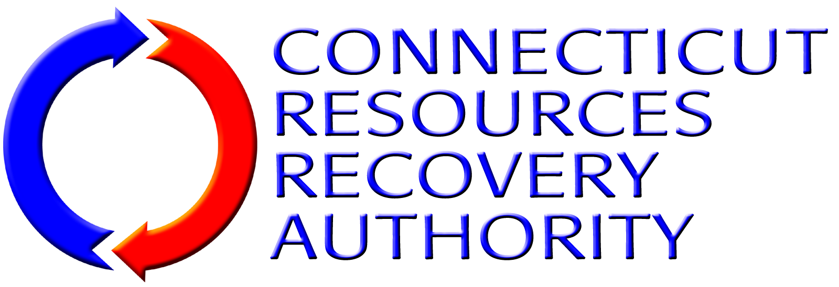
BUSINESS DISCLOSURE FORM

CONFLICTS OF INTEREST
In the table below, disclose any material assignments, relationships or other employment that the proposer or any employee of the proposer has with any member of CRRA’s past or present Board of Directors, any CRRA employee, law firms, governmental entity, or other person or entities that may create a conflict of interest or the appearance of a conflict of interest in providing insurance consulting and broker services to CRRA.
[Attach Additional Pages If Necessary]

CONFLICT OF INTEREST MEASURES
In the table below, discuss any measures that the proposer either has in place or would take to identify, disclose and resolve any possible conflicts of interest.
[Attach Additional Pages If Necessary]

BUSINESS WITH MAJOR CRRA CONTRACTORS
In the table below, disclose any insurance consulting and/or broker services that the proposer has provided to any of the following major CRRA contractors. Place a check in the box for any such contractor for which the proposer has provided the services. If the proposer has provided any such services, provide a summary description of the services provided.
Having provided insurance consulting and/or broker services to one or more of the contractors listed below does not disqualify a proposer from consideration under this RFP.
[Attach Additional Pages If Necessary]
Entity |  | Summary Description of Services Provided
 | Covanta
 | Copes Rubbish Service
 | CWPM, LLC
 | The Metropolitan District
 | NAES Corporation
 | Wheelabrator (Waste Management)

