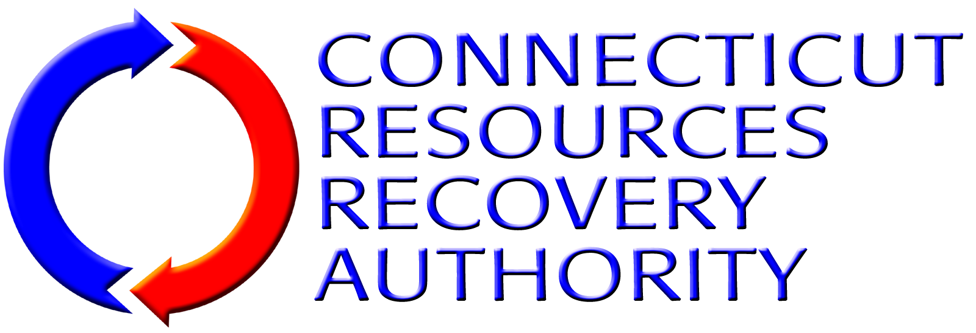
AFFIDAVIT CONCERNING NONDISCRIMINATION
This Affidavit must be completed and properly executed under penalty of false statement by a chief executive officer, president, chairperson, member or other corporate officer duly authorized to adopt company, corporate or partnership policy of the business entity submitting a bid/proposal/statement of qualifications to the Connecticut Resources Recovery Authority that certifies such business entity complies with the nondiscrimination agreement and warranties contained in Connecticut General Statutes §§ 4a-60(a)(1) and 4a-60a(a)(1), as amended, regarding nondiscrimination against persons on account of their race, color, religious creed, age, marital status, national origin, ancestry, sex, mental retardation, mental disability, physical disability or sexual orientation.
I, the undersigned, am over the age of eighteen and understand and appreciate the obligation of an oath.
I am |  |  |  |  |  |  | (title) of
 |  |  |  |  |  | (firm name), an entity duly
formed and existing under the laws of |  |  |  |  | (name of state or commonwealth)
(“Contractor”).
I certify that I am authorized to execute and deliver this affidavit on behalf of Contractor, as follows:
 |  | 1. | Contractor seeks to enter into the “Agreement for the Purchase of a Mobile Grapple-Crane for the Mid-Connecticut Waste Processing Facility” (the “Agreement”) with the Connecticut Resources Recovery Authority; and
 |  | 2. | Contractor has in place a company or corporate policy that complies with the nondiscrimination agreements and warranties required under Connecticut General Statutes §§ 4a-60(a)(1) and 4a-60a(a)(1), as amended, and the said company or corporate policy is in effect as of the date hereof.

By (Signature):
Name (Print):
Title:

Sworn to before me this |  | day of |  | 20

Notary Public/Commissioner of the Superior Court Commission Expiration Date

