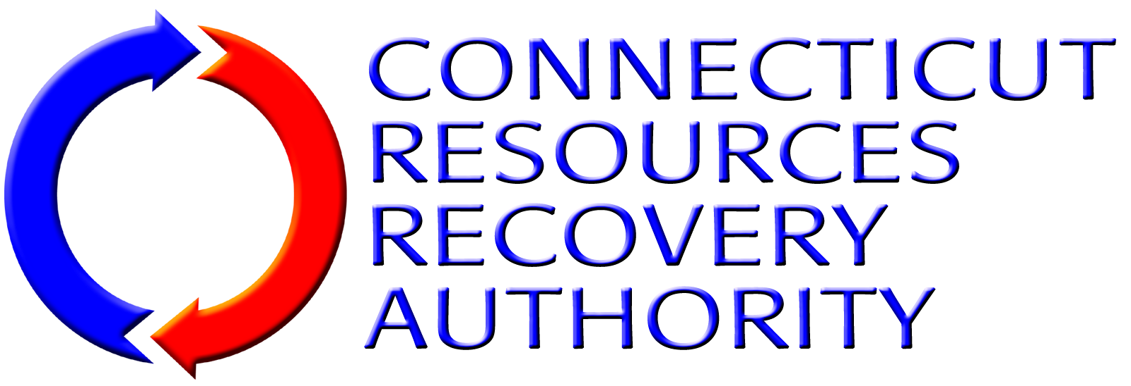
STATEMENT OF QUALIFICATIONS FORM

PROJECT: | Mid-Connecticut
RFQ NUMBER: | FY10-OP-002
CONTRACT FOR: | Operation & Maintenance of the Mid-Connecticut Resource Recovery Facility
SOQ SUBMITTED TO: | Connecticut Resources Recovery Authority  100 Constitution Plaza, 6th Floor  Hartford, Connecticut 06103-1722

BUSINESS MODEL(S) FOR WHICH STATEMENT OF QUALIFICATIONS SUBMITTED
In the table below, place a check mark in the box for each Business Model for which the entity submitting this Statement Of Qualifications (“SOQ”) wishes to be considered. (The Scope Of Services for each Model is described in Services Overview And Qualifications Submittal Requirements.
Business Model 1 – O&M of the Facility via a Management Agreement
Business Model 1 – O&M of the Facility via an Executive Agreement

SUBMITTER’S REPRESENTATIONS CONCERNING EXAMINATION OF RFQ DOCUMENTS
In submitting this SOQ, Submitter represents that:
- Submitter has thoroughly examined and carefully studied the RFQ package documents and the following Addenda, receipt of which is hereby acknowledged (list Addenda by Addendum number and date):
Addendum Number | Date Issued

SUBMITTER’S REPRESENTATIONS CONCERNING INFORMATION MADE AVAILABLE
In submitting this SOQ, Submitter acknowledges and agrees that Submitter shall not use any information made available to it or obtained in any examination made by it in connection with this RFQ in any manner as a basis or grounds for a claim or demand of any nature against CRRA arising from or by reason of any variance which may exist between information offered or so obtained and the actual materials, conditions, or structures encountered during performance of any of the Work.

SUBMITTER’S REPRESENTATIONS CONCERNING DISCLOSURE OF INFORMATION
In submitting this SOQ, Submitter:
- Recognizes and agrees that CRRA is subject to the Freedom of Information provisions of the Connecticut General Statutes and, as such, any information contained in or submitted with or in connection with Submitter’s SOQ is subject to disclosure if required by law or otherwise; and
- Expressly waives any claim(s) that Submitter or any of its successors and/or assigns has or may have against CRRA or any of its directors, officers, employees or authorized agents as a result of any such disclosure.

SUBMITTER’S REPRESENTATIONS CONCERNING NON-COLLUSION
By submission of this SOQ, the Submitter, together with any affiliates or related persons, the guarantor and any joint ventures, hereby represents that, under risk of termination of the Agreement, if awarded, to the best of its knowledge and belief:
- No attempt has been made or will be made by the Submitter to induce any other person, partnership of corporation to submit, or not to submit, an SOQ for the purpose of restricting competition;
- Submitter has not directly or indirectly induced or solicited any other entity to submit a false or sham SOQ; and
- Submitter has not sought by collusion to obtain for itself any advantage for the Services over any other submitter for the Services or over CRRA.

SUBMITTER’S REPRESENTATIONS CONCERNING RFQ FORMS
By submission of this SOQ, the Submitter, together with any affiliates or related business entities or persons, the guarantor and any joint ventures, hereby represents that, under risk of termination of the Agreement, if awarded, all of the forms included in the RFQ that are submitted to CRRA as part of its SOQ are identical in form and content to the preprinted forms in the RFQ except that information requested by the forms has been inserted in the spaces on the forms provided for the insertion of such requested information.

SUBMITTER’S WAIVER OF DAMAGES
Submitter and all its affiliates and subsidiaries understand that by submitting a SOQ, Submitter is acting at its and their own risk and Submitter does for itself and all its affiliates, subsidiaries, successors and assigns hereby waive any rights any of them may have to receive any damages for any liability, claim, loss or injury resulting from:
- Any action or inaction on the part of CRRA or any of its directors, officers, employees or authorized agents concerning the evaluation, selection, non-selection and/or rejection of any or all SOQS by CRRA or any of its directors, officers, employees or authorized agents.

SUBMITTERS REPRESENTATION REGARDING THE CONNECTICUT CAMPAIGN CONTRIBUTION AND SOLICITATION BAN
With regard to a State contract as defined in P.A. 07-1 having a value in a calendar year of $50,000 or more or a combination or series of such agreements or contracts having a value of $100,000 or more, the authorized signatory to this submission in response to CRRA’s solicitation expressly acknowledges receipt of the State Elections Enforcement Commission’s notice advising prospective state contractors of state campaign contribution and solicitation prohibitions, and will inform its principals of the contents of the notice. See Exhibit 2 [SEEC Form 11] of the RFQ Documents.

ATTACHMENTS
The following documents are attached hereto and made a part of this Bid:
- The completed Statement of Qualifications Form (Exhibit 4 to the RFQ Package Documents) ;
- The completed Background Questionnaire (Exhibit 5 to the RFQ Package Documents) ;
- The completed References Form (Exhibit 6 to the RFQ Package Documents);
- The completed Background and Experience (Exhibit 7 to the RFQ Package Documents); and
- The completed Issues and Questions to Be Addressed (Exhibit 8 to the RFQ Package Documents).

NOTICES
Communications concerning this SOQ should be addressed to Submitter at the address set forth below.
Submitter Name:
Submitter Contact:
Title:
Address:
Telephone Number:
Fax Number:
E-Mail Address:

ADDITIONAL REPRESENTATION
Submitter hereby represents that the undersigned is duly authorized to submit this SOQ on behalf of Submitter.
AGREED TO AND SUBMITTED ON |  | , 200 | 9

Name of Submitter (Firm):
Signature of Submitter Representative:
Name (Typed/Printed):
Title (Typed/Printed):

