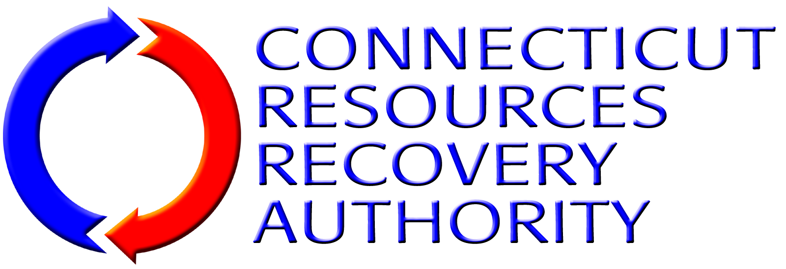
BUSINESS DISCLOSURE FORM

CONFLICTS OF INTEREST
In the table below, disclose any material assignments, relationships or other employment that the SOQ submitter or any employee of the SOQ submitter has with any member of CRRA’s past or present Board of Directors, any CRRA employee, law firms, governmental entity, or other person or entities that may create a conflict of interest or the appearance of a conflict of interest in providing consulting, engineering and land surveying services to CRRA.
[Attach Additional Pages If Necessary]

CONFLICT OF INTEREST MEASURES
In the table below, discuss any measures that the SOQ submitter either has in place or would take to identify, disclose and resolve any possible conflicts of interest.
[Attach Additional Pages If Necessary]

BUSINESS WITH MAJOR CRRA CONTRACTORS
In the table below, disclose any consulting, engineering and/or land surveying services that the SOQ submitter has provided to any of the following major CRRA contractors. Place a check in the box for any such contractor for which the SOQ submitter has provided the services. If the SOQ submitter has provided any such services, provide a summary description of the services provided.
Having provided consulting, engineering and/or land surveying services to one or more of the contractors listed below does not disqualify an SOQ submitter from consideration under this RFQ.
[Attach Additional Pages If Necessary]
Entity |  | Summary Description of Services Provided
 | Covanta
 | The Metropolitan District
 | CWPM, LLC
 | Copes Rubbish Service
 | Wheelabrator (Waste Management)

