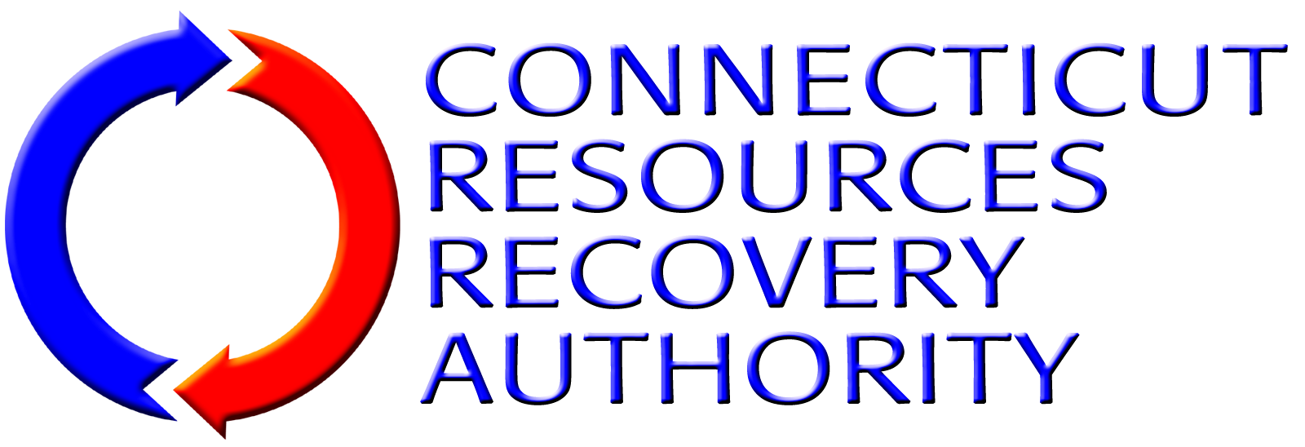
NOTICE OF INTEREST FORM
Individuals and firms that have an interest in the Connecticut Resources Recovery Authority (“CRRA”) solicitation listed below are encouraged to submit this Notice Of Interest Form to CRRA as early as they can. Forms should be submitted no later than the date specified below. Request For Qualifications and Proposal documents and other information released by CRRA related to the solicitation will be directly provided to those firms that have submitted this Form to CRRA by the Form Due Date.
Solicitation: | Transportation and Disposal of Process Residue, Non-Processible MSW and Bypass MSW
Form Due Date: | 3:00 p.m., Tuesday, November 27, 2007
Provide the following information about the individual/firm and the contact person for the firm.
Name of Individual/Firm:
Name of Contact Person:
Title of Contact Person:
Mailing Address:
Telephone Number:
Fax Number:
E-Mail Address:
Submit this form to the CRRA contact listed below via e-mail, fax or correspondence as listed below.
CRRA Contact: | Peter Egan, Director of Environmental Affairs and Development
E-Mail Address: | pegan@crra.org
Fax Number: | (860) 757-7742
Correspondence Address: | Connecticut Resources Recovery Authority  100 Constitution Plaza, 6th Floor  Hartford, CT 06103

